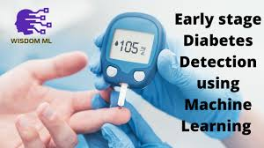

**Overview**

Diabetes is a common condition. The CDC found that 30.3 million adults in the U.S. have diabetes. They also estimate that 80.4 million adults have prediabetes. Diabetes can be difficult to live with and be expensive to treat. Therefore, diagnosing diabetes early can be helpful to a person’s way of life and wallet.

**Data**

A dataset of people with diabetic symptoms was found on Kaggle. It was put there by the UC Irvine (UCI) Center for Machine Learning and Intelligent Systems. The data contains information collected from questionnaires from newly diabetic or would be diabetic patients of Sylhet Diabetes Hospital in Sylhet, Bangladesh. There are 520 instances (patients) with 15 possible features (symptoms) and their class (whether they have or do not have diabetes). 320 instances are Positive for diabetes and 200 are Negative for diabetes.

**Data Wrangling**

The dataset did not have any missing values.

Some of the analysis requires the data to be integers rather than text. Therefore, a dataframe was created changing the literals ‘Yes/No’, ‘Female/Male’, and ‘Positive/Negative’ to the integers 1/0, respectively.

**Exploratory Data Analysis**

**Correlation Heatmap**

A correlation heatmap was created to see what features (symptoms) relate to the class (whether they have or do not have diabetes). Only two features had more than a 50% correlation to the class (whether they have or do not have diabetes). Polyuria has a 67% correlation and Polydipsia has a 65% correlation. That is not too good by itself so further analysis is needed.

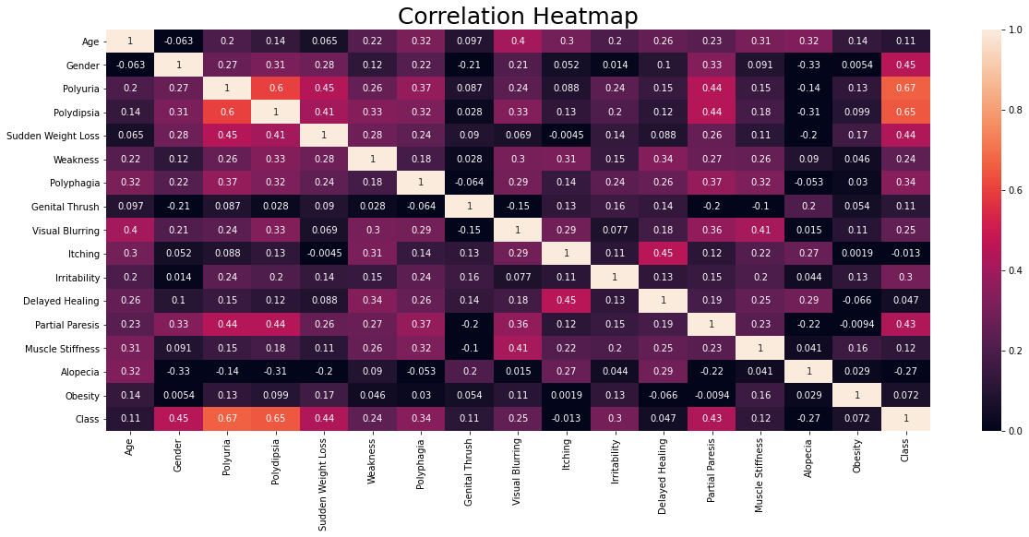

**Feature Analysis**

Each of the features was analyzed with respect to whether a patient had diabetes or not.

**Positive v Negative**

There are 320 instances of patients with diabetes (Positive) and 200 instances of patients without diabetes (Negative).

**Age**

Patients in their 60’s had the highest chance of diabetes at 74%. Patients in their 30’s and 50’s had a 62% chance of having diabetes and patients in their 40’s had a 58% chance of having diabetes. Patients in their 20’s and 70’s had less than a 50% chance of having diabetes.

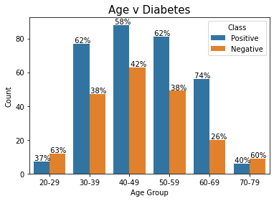

**Gender**

Females had a 90% chance of having diabetes and males had a 45% chance of having diabetes.

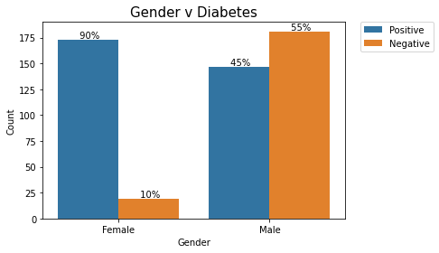

**Polyuria**

Patients with Polyuria had a 94% chance of having diabetes.

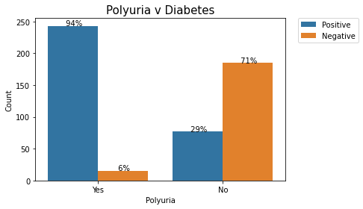

**Polydipsia**

Patients with Polydipsia had a 97% chance of having diabetes.

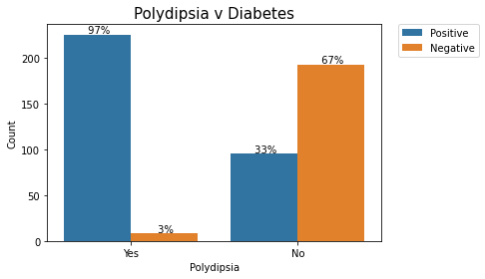

**Sudden Weight Loss**

Patients with Sudden Weight Loss had a 87% chance of having diabetes.

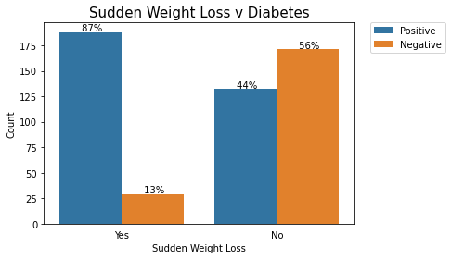

**Weakness**

Patients with Weakness had a 71% chance of having diabetes.

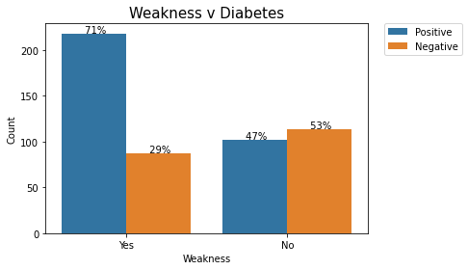

**Polyphagia**

Patients with Polyphagia had a 80% chance of having diabetes.

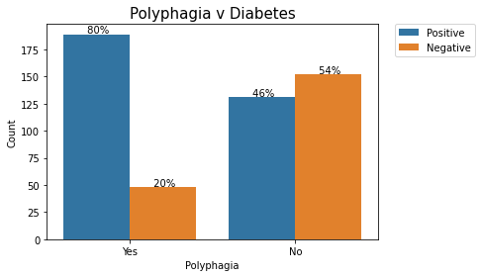

**Genital Thrush**

Patients with Genital Thrush had a 72% chance of having diabetes.

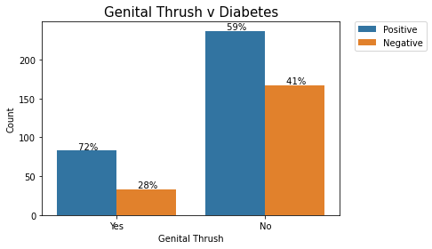

**Visual Blurring**

Patients with Visual Blurring had a 75% chance of having diabetes.

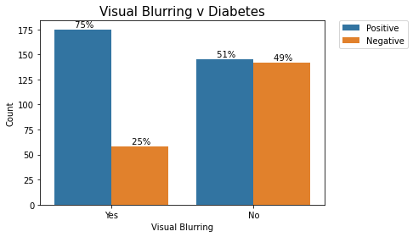

**Itching**

Patients with Itching had a 61% chance of having diabetes.

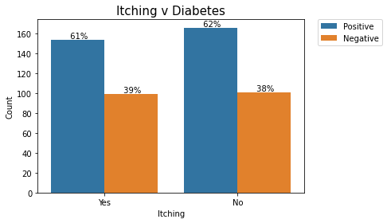

**Irritability**

Patients with Irritability had a 87% chance of having diabetes.

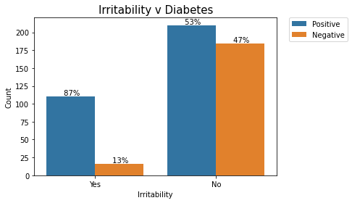

**Delayed Healing**

Patients with Delayed Healing had a 64% chance of having diabetes.

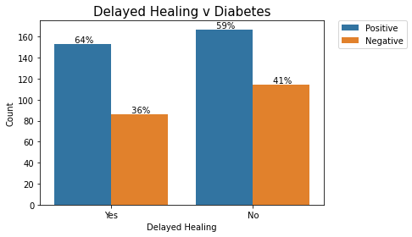

**Partial Paresis**

Patients with Partial Paresis had a 86% chance of having diabetes.

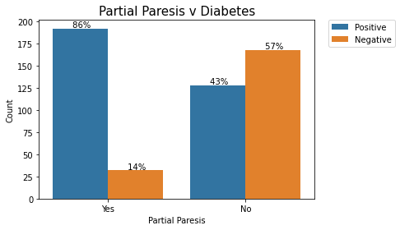

**Muscle Stiffness**

Patients with Muscle Stiffness had a 69% chance of having diabetes.

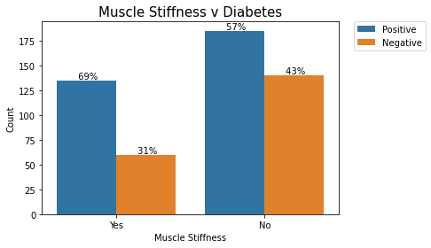

**Alopecia**

Patients with Alopecia had a 44% chance of having diabetes.

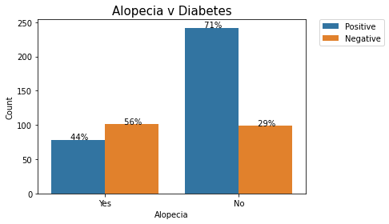

**Obesity**

Patients with Obesity had a 69% chance of having diabetes.

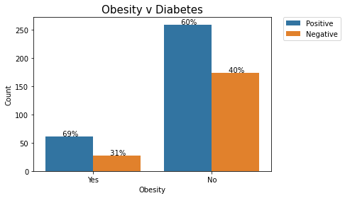

**Model Analysis**

**Logistic Regression with Scaling**

Accuracy on training set: 0.940

Accuracy on test set: 0.929

Note: The data needed to be scaled in order to do Logistic Regression

**Decision Tree**

Accuracy on training set: 0.995

Accuracy on test set: 0.936

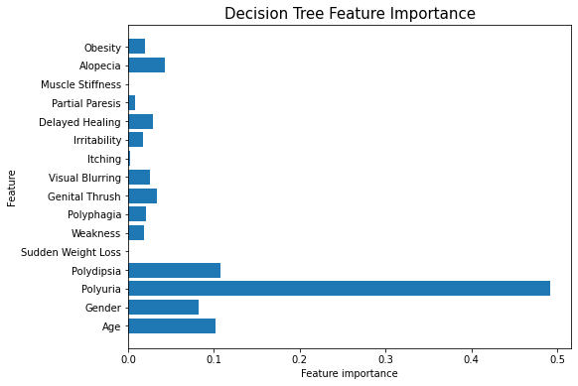

**Gradient Boosting**

Accuracy on training set: 0.997

Accuracy on test set: 0.949

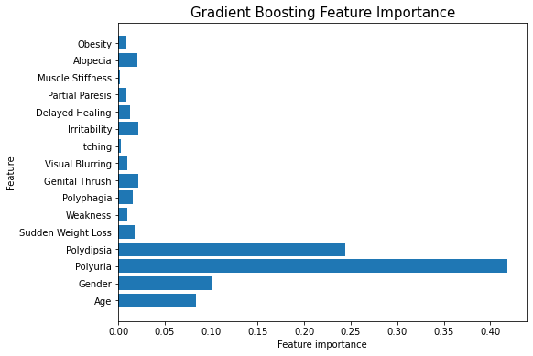

**Random Forest**

Accuracy on training set: 1.000

Accuracy on test set: 0.981

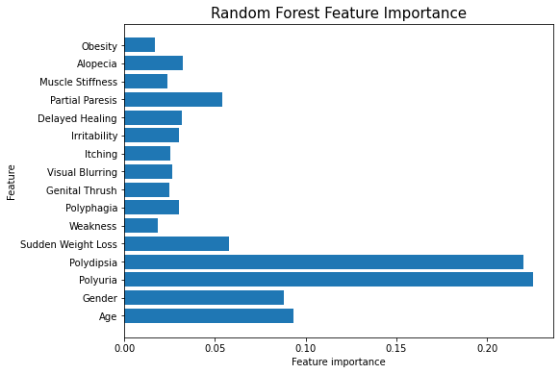

**Summary of Results (greater than 40%)**

Correlation Heatmap Polyuria 67%

Correlation Heatmap Polydipsia 65%

Correlation Heatmap Gender 45%

Correlation Heatmap Sudden Weight Loss 44%

Correlation Heatmap Partial Paresis 43%

Feature Analysis Age – 60’s 74%

Feature Analysis Age – 30’s, 50’s 62%

Feature Analysis Age – 40’s 58%

Feature Analysis Age – 70’s 40%

Feature Analysis Gender – Female 90%

Feature Analysis Gender – Male 45%

Feature Analysis Polyuria 94%

Feature Analysis Polydipsia 97%

Feature Analysis Sudden Weight Loss 87%

Feature Analysis Weakness 71%

Feature Analysis Polyphagia 80%

Feature Analysis Genital Thrush 72%

Feature Analysis Visual Blurring 75%

Feature Analysis Itching 61%

Feature Analysis Irritability 87%

Feature Analysis Delayed Healing 86%

Feature Analysis Partial Paresis 86%

Feature Analysis Muscle Stiffness 69%

Feature Analysis Alopecia 44%

Feature Analysis Obesity 69%

Model Logistic Regression with Scaling 93%

Model Decision Tree 94%

Model Gradient Boosting 95%

Model Random Forest 98%

**Conclusion**

The Correlation Heatmap gave us a good initial idea about what features may be useful. 5 features gave 40% - 67% correlation to determine whether a person has diabetes. 67% correlation is not very high.

Feature Analysis gave us 20 features with 40% - 97% probability of determining whether a person has diabetes. Some features had a pretty good probability of determining whether a person has diabetes but not all patients had those symptoms so this is good if the patient has the high probability symptom but not as good if the patient does not have a high probability symptom.

Modelling gave us 93% - 98% probability of determining whether a person has diabetes. This is very good. Random Forest gives us the maximum probability of determining whether a person has diabetes at 98%.

Early detection of diabetes can be very beneficial to a person’s way of life and to their pocketbook. The use of machine learning can help predict diabetes with 98% accuracy.

**For Future Consideration**

The data had only 520 instances. Collecting more data may help to make the model prediction more accurate.